Dissertation proposal by Lea (Shuchan) Lai.
Committee members: Richard Shiffrin, chair, Rob Nosofsky, Jerome Busemeyer, Michael Trosset
The Role of Context in Memory Storage and Retrieval:
Insights from Recognition and Recall Studies through Computational Modeling
Introduction
Memory is often conceptualized as comprising two crucial components: content and context. Content refers to the specific details that distinguish one memory from another, even when both occur within the same setting. Context, on the other hand, encompasses the situational details surrounding an event, details that are often largely the same for events occurring nearby in time. For example study of a list of words may produce memory traces for those words that differ in content, but include context that is similar for all the word traces. Context plays a critical role in focusing retrieval on specific events, a process fundamental to episodic memory.
Research suggests that context changes gradually over time and with the occurrence of new events (Mensink & Raaijmakers, 1988). Previous experiments have shown that context remains relatively stable during the study of a list but tends to shift between study and test phases. Additionally, testing appears to alter context more significantly than study does. Context is typically stored automatically for a brief period—often a second or two—while additional study time is allocated to storing content, such as the meaning of the items (Malmberg & Shiffrin, 2005).
The relationship between content and context in memory storage is not fully understood. Context may be integrated with content or stored separately (Murnane, Phelps & Malmberg, 1999). Most memory studies probe retrieval using the current context at the time of testing, thereby focusing retrieval on recent events. However, a key question remains: can reconstructing the context from the time of storage facilitate the retrieval of past events? Although research on this question is limited, recent evidence suggests that it is possible even for memory for words on lists (Bauml & Trissl, 2022).
Despite the critical role of context in memory, it is seldom varied in experimental studies. When attempts are made to manipulate context—such as by changing the room for testing—these manipulations often produce minimal effects. This may be because the manipulated aspect of context represents only one of many elements that collectively define the contextual framework.
Given the rudimentary nature of current models of context, which generally assume little more than its gradual change over time and across different settings, the present study was designed to explore the role of context in memory in greater depth. This investigation aims to contribute to the development of a more detailed model of context's influence on memory, particularly within the REM (Retrieving Effectively from Memory) framework, which has demonstrated considerable efficacy in previous studies.
My dissertation will include a study that bears on these issues that has recently been published, a study that explored the joint use of long-term and short term memory in short-term probe recognition (Lai, Cao & Shiffrin, 2024); that model incorporated an important role for context. That publication and model is long and complex and will not be discussed in this presentation and planning document. In this document I will discuss two studies that were conducted to examine these issues, and at least one more that is planned. In Study 1, participants were tested on picture recognition, while in Study 2, participants were tested on cued recall for words. Both studies employed similar designs, with accuracy and response time as key measures.
Objectives:
- To investigate the role of context in memory storage and memory retrieval of events (i.e. episodic memory).
- To develop and refine a detailed computational model of event memory that will delineate the role of context.
- To produce a model, as simple as possible, that will capture the major patterns of performance accuracy from studies of recognition and cued recall. These patterns will include differences due to words and pictures, list length, primacy and recency, output interference, initial study and test versus end of session testing, serial position effects within list and list position effects within session and end of session, and differences due to presentation of context information.
Modeling objectives:
- The focus will be on variants of the REM model (Retrieving Effectively from Memory), because it has been the best simplest model of recognition memory for events.
- REM was designed to produce optimal decisions for recognition of items studied on lists; the dissertation will explore its ability to predict cued recall.
- Other models will be discussed and to the extent possible compared to REM.
- The primary goal will be prediction of the form of data patterns from many studies, not just predicting the results from our new studies quantitatively.
Methodology:
- Several lists of words and pictures are studied, each followed by tests of recognition, and in the case of words, followed by cued recall or recognition.
- At session end there will be tests of all items seen during session; these tests will be recognition and in the case of words, recognition or cued recall.
- Some end of session tests will provide information about the list on which a test item might have been studied. Other end of session tests will not provide such information.
Current Progress:
Two studies using web participants have been completed thus far. There are 200 participants recruited for study 1, and 375 participants recruited for study 2.

Study 1: Recognition for Pictures
In the first study, participants engaged in two phases of picture recognition task. In initial phase, they were presented with ten lists, each containing twenty pictures. After studying each list, a digital counting test was included to clear short term memory. Then, participants were tested on ten target pictures (pictures they had just studied) and ten foils (pictures not previously seen during the study). After an instructional break, a final phase of test was conducted: participants were tested on recognition of old pictures (targets) that are randomly selected from 70% of all pictures encountered in prior test, and equal number of new pictures (foils) that have never been seen before. In final test, there are three types of old pictures —those they had only studied but not tested, those they had been studied and tested on, and those that were only seen during testing (foils in prior test). Each of the three types of pictures from the 10 previous lists contains 10 pictures. Out of these, seven were selected from each kind in each list, resulting in a total of 210 targets (3 types * 7 pictures * 10 lists). These were mixed with 210 foils in the final test.
The final test included three groups.
- Forward group: Pictures from the initial study lists (final targets) were tested in the forward order of their list occurrence. An equal number of final foils were randomly mixed within each block of 21 (3 types * 7 pictures) targets, making 42 tests in each block. Participants were informed of the test order at the beginning of the final test, and the list number of targets were also presented before each block of tests. The foils don’t have a prior list number but would also be mixed within each block of tests.
- Backward group: Pictures from the initial study lists (final targets) were tested in the backward order of their list occurrence. Similar to the forward condition, 42 tests were included in each block. Same instructions were given except of course the information informing the order of testing targets was reversed.
- Random group: 210 pictures from the initial test (final targets) were randomly mixed with 210 new foils. Therefore, no list number or order of testing was provided.
Study 2: First Two-Letter Cued Recall of Words
Study 2 had two phases of tests similar to study 1 but focused on cued recall using word lists. In the initial phase participants studied ten lists, each containing twenty words, resulting in a total of 200 study words. After studying each list, a digital counting task was included in clearing short term memory. Followed by that, eight words from the studied ones were randomly selected to test; the first two letters were used as cues. The participants were asked to type the entire word if they remembered it from the current study list based on the provided first two letters and type ‘none’ if they cannot recall. Responses were required.
These lists were organized into successive pairs (1, 2; 3, 4; …; 9, 10). Each pair of lists was structured as follows: Ten words shared the same first two letters, which were unique across all list pairs. This created 50 unique first-letter pairs. Each list also had ten words with unique first two letters that did not appear in any other list, adding another 100 unique first-letter pairs.
In total, 150 different first-letter pairs were used across the 200 study words.
In each list, participants were tested on: (1) Paired words: Three of the ten words sharing the first two letters within the pair of lists were randomly selected. (2) Unique words: Five of the ten totally unique words within that list were randomly selected. When paired words were tested in the later list in each pair, the cued first two letters are associated with words in both lists; however, participants were instructed to recall only the most recently presented word with those initial letters.
After the ten lists had been studied and tested, participants were given an instructional break and then underwent a final cued recall test with all 150 different first-letter pairs. They were instructed to type one word that started with the given first two letters from the study phase; if they remembered two words starting with those letters, they were instructed to type the word best remembered.
There were five groups of final testing. In the forward group, participants were tested on the first-letter pairs in the order of the study lists, starting from the first list to the last, and before each group of tests were informed about the list number for those tests. In the backward group, participants were tested on the first-letter pairs in reverse order, starting from the last list back to the first, and also informed about the list number for each group of tests. In the forward random group, participants were tested on the order of first, last, second first, second last, and so on, again learning the list number for each test group. In the backward random group, participants were tested on the order of last, first, second last, second first, and so on, again being told the list number for each set of tests. In the random group, participants were tested on a random mix of the 120 first-letter pairs, and were not told the list number for any of the tests.
Analysis and Modeling for the First Study
The analysis is mostly done for study one and partly done for study two. The modeling is well underway for study one only.
Modeling Structure for Study One (likely to be extended for Study Two and the planned new study).
- REM has been used successfully to explain and predict recognition data. Thus, as a first step, an extended REM model is being used to predict the recognition data from Study One. The results predicted are within list performance and between list performance during the study and testing of the initial ten lists, and final test performance for all conditions. The REM model is extended to include 1) a filter determining which memory traces are activated prior to application of regular REM; 2) context change during testing; 3) strengthening of certain traces during testing; 3) storage of new traces during testing; 4) differential context cues used in different conditions of final testing.
Results for Study One
- Within list results during Initial Testing
Figure 1 shows results with standard errors of the mean for each data point.
First, there is some primacy and a small amount of recency when we analyze by study position, (left panel of Figure 1). Second, there is no evidence for output interference within initial testing (decreasing performance as testing continues), and in fact there is a small increase in performance measured by the average of correct rejections and hits (black line in the right panel of Figure 1). Third, there are higher correct responses to foils (‘correct rejections’ or CRs) than to targets (‘hits’ or Hs), the difference decreasing as testing continues. I note that previous studies of output interference in recognition testing (i.e. Criss, Malmberg & Shiffrin, 2011, and Annis, Malmberg, Criss & Shiffrin, 2013) used longer lists and more extended testing, and found decreasing performance (i.e. output interference) as testing continued. However they did find increasing performance at the start of testing (consistent with the findings from the present study) something that their model did not explain. It seems likely that extended testing would have reversed the increasing performance seen in our study.
Our current best model to explain these results stores new traces for items judged new during testing and strengthens existing traces for items judged old. It has a first stage filter that only activates traces similar to both context and content in the probe of memory. This process selectively activates traces more similar to the probe than would occur without testing effects. The model also seems to require context change during testing. Therefore, the increasing of hits and decreasing of false alarms during testing could be explained by having the filter that prevents activation of traces that poorly match the probe in context and content. The strengthened trances become less similar, so the filter tends not to activate them. This could potentially decrease correct rejections, increase hits, and amplifies these effects as testing continues.
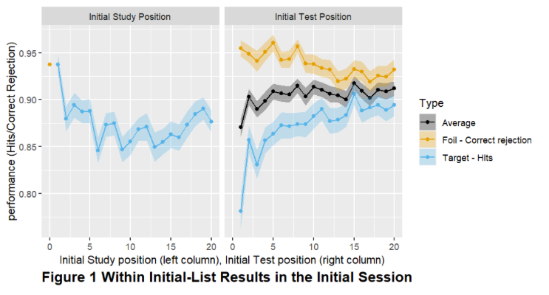
- Within-List results during Final testing (Figure 2)
First, the item study position during the initial phase has minimal influence on their recognition in final testing (left panel of Figure 2).

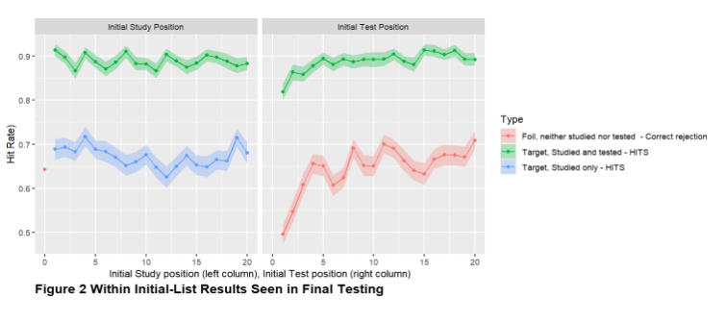
Second, in final testing, items tested from more recent test positions within the initial testing (right panel of Figure 2) are more likely to be recognized. This could be due to the increase in performance seen in initial testing as testing continued, possibly because these items benefit from associations with previously recalled pictures.
- Between-List Results during Initial Testing (Figure 3):
Figure 3 shows performance by list in initial testing. The correct rejections remain mostly constant but there is a substantial decrease in hit rates (Hs) as list continue. This decline is likely due to the activation of memory traces from prior lists, contributing to increased context noise. One can view this as a form of output interference, but here interference due to study and testing of lists, rather than interference during testing of one list.
The REM model with a fixed criterion of 1.0 for recognition decisions predicts that correct rejections (CRs) will be higher than hit rates (Hs), which is consistent with the later pattern of the results here. The particular pattern of the changes of hits in Figure 3 will be the subject of continued modeling.

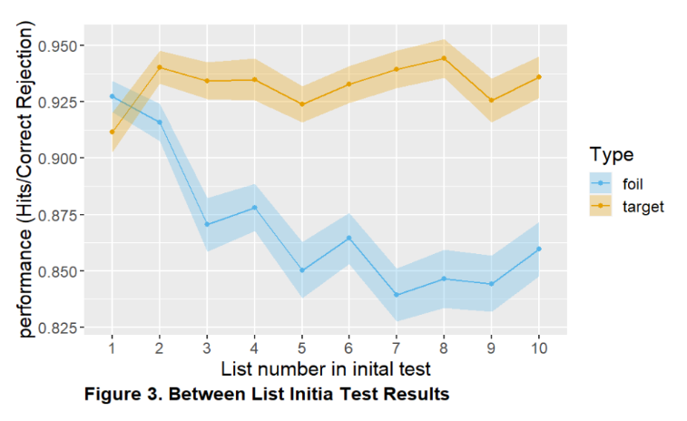
- Between List Result of Final Test by final test position
Figure 4 shows how performance changes as final testing continues, as a function of the final test list position, for random, backward, and forward test conditions.

  - The data shown in blue shows foils in final testing, and as usual correct rejection for foils is quite high.
  - In all three conditions targets correctly recognized in initial testing (i.e. given ‘hits’) are recognized best. Performance for items initially studied but not tested (in orange) and items tested as foils (in yellow) were recognized much worse in final testing; in both final hit rate was lower by about 0.20 – 0.25 than for initial targets given hits. The higher performance for initial targets is likely due to strengthening of the target traces during initial testing. The fact that final testing of items studied but not tested is about equal to final testing of foils initially tested suggests that storage of a new trace when an item is studied (but not tested) is about equal to storage of a trace due to testing only (e.g. storage of a new trace for an item judged new).
  - The random condition serves as a baseline, showing a general decrease in performance as testing continues. This decrease seems to occur for both final foils as well as the various types of final targets (and does so for the forward and backward conditions as well), in contrast to initial testing when foils remain high and stable both within list and between list (Figures 2 and 3). It will be an interesting challenge to model this difference. Generally speaking, REM works well with a decision criterion of odds of 1.0 for every condition. Modeling the relation of correct rejections to hits as testing continues might require some modest adjustment of the decision criterion.
  - Recall that the participants in the backward and forward conditions were told the initial test list position of targets, in the hope of determining whether they could appropriately adjust their context cue to improve their performance (in comparison with the random condition, in which knowledge of the list being tested would be missing). If participants were unable to make use of the list information, then the backward and forward conditions would be identical to each other and to the random condition. Analysis is still continuing but thus far suggests that there are differences between the three conditions. If so, participants may have some ability to adjust their context cues when given information about the lists from which targets are being tested.
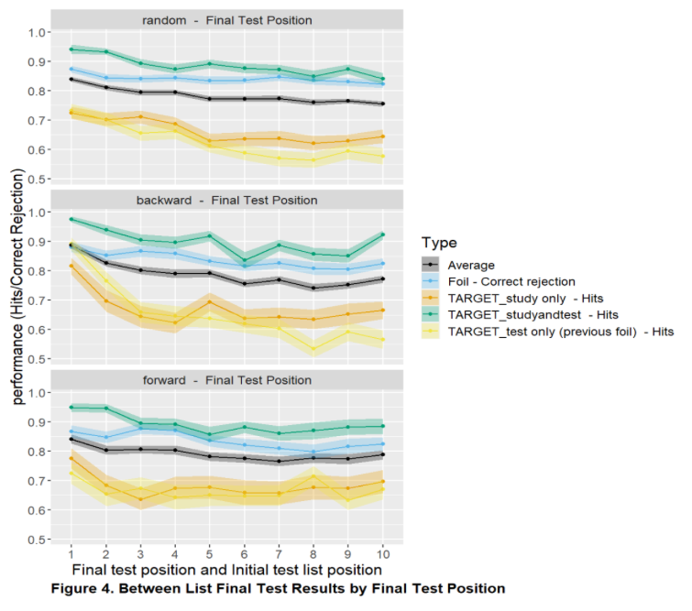
  - Between List Result of Final Test by initial list position
Figure 5 shows results from the random test condition that allows an unconfounded analysis of final performance as a function of initial list position. Final test performance by initial list position (1-10) reveals modest primacy and recency effects. These results are in striking contrast to the changes in performance as lists continue in initial testing, shown in Figure 3: In Figure 3, a general decrease occurs as lists continue, a decrease that is produced by decreases in hits. Accounting for the differences between Figures 3 and 5 might require differences in the context cues used in initial and final testing, differences in fidelity of storage during initial study and testing as lists continue, and possibly some small differences in the decision criteria in these various conditions. These possibilities are the subject of present investigation.
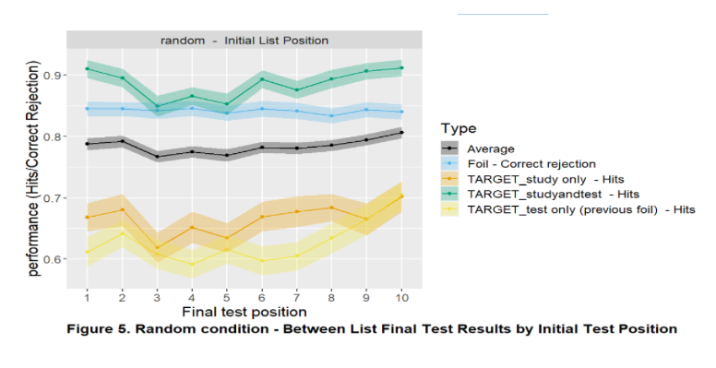
Plans for additional studies:
- I believe the analysis and modeling of Studies 1 and 2 will probably be sufficient to justify a dissertation, particularly since REM has been used for recognition and extending it to cued recall will be a large enterprise in itself. Nonetheless I am considering another study to help determine the best model for memory storage and retrieval that explains the roles of context.
- The analysis and modeling of Study 1 suggests further information about the use and role of context in storage and testing would be obtained by initial tests carried out by recognition or cued recall, and the final testing carried out by the other. This can only be done for word lists (and of course it would be useful to have recognition data for word lists as well as pictures).
- Thus I tentatively plan an additional study with three conditions for word lists: 1) An experiment like Study 1, a recognition study, but using words. 2) Initial testing will be cued recall and final testing by recognition; 2) Initial testing will be recognition and final testing by cued recall.
- In the course of modeling it may become clear that an additional study or studies is or are needed, and these might be carried out, but are not part of the present proposal.
References
Annis, J., Malmberg, K. J., Criss, A. H., & Shiffrin, R. M. (2013). Sources of interference in recognition testing. Journal of Experimental Psychology: Learning, Memory, and Cognition, 39(5), 1365.
Bäuml, K. H. T., & Trißl, L. (2022). Selective memory retrieval can revive forgotten memories. Proceedings of the National Academy of Sciences, 119(8), e2114377119.
Criss, A. H., Malmberg, K. J., & Shiffrin, R. M. (2011). Output interference in recognition memory. Journal of Memory and Language, 64(4), 316-326.
Lai, S. L., Cao, R., & Shiffrin, R. M. (2024). Recognition memory decisions made with short-and long-term retrieval. Memory & Cognition, 1-24.
Malmberg, K. J., & Shiffrin, R. M. (2005). The" one-shot" hypothesis for context storage. Journal of Experimental Psychology: Learning, Memory, and Cognition, 31(2), 322.
Mensink, G. J., & Raaijmakers, J. G. (1988). A model for interference and forgetting. Psychological Review, 95(4), 434.
Murnane, K., Phelps, M. P., & Malmberg, K. (1999). Context-dependent recognition memory: the ICE theory. Journal of Experimental Psychology: General, 128(4), 403.

